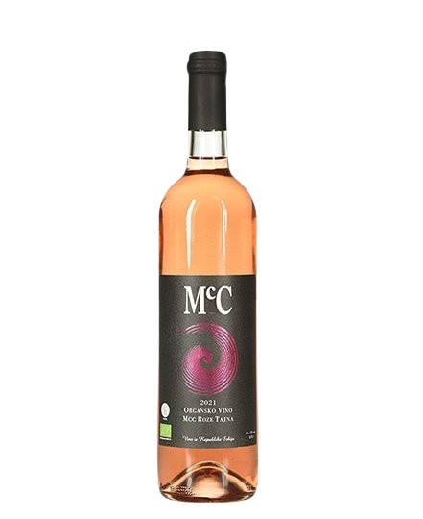

Qwwdq

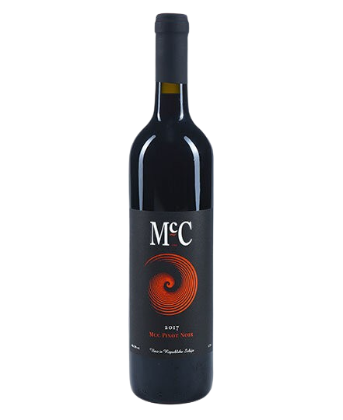
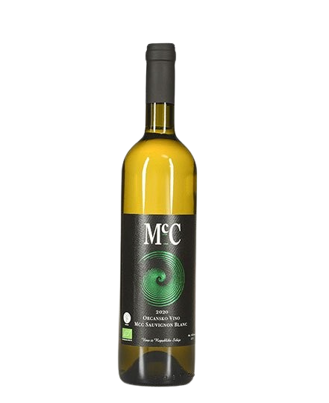
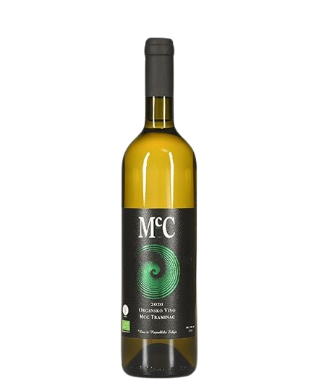
Rose Tajna
- Dry rosé wine-

About the vine

Grape varieties:
- Merlot
- Cabarnet Sauvignon
Origin: Erdevik, Fruška Gora
Serving temperature:8-10 ºC

A fresh, light wine with a well-balanced body. The nose features floral notes and red fruit, with subtle hints of herbs and spices. On the palate, it is light in structure with a longer finish.
Food pairings include lighter dishes such as young cheeses, pasta, pizza, and salads.
Grape varieties: 50% Merlot and 50% Cabernet Sauvignon.
Aging: minimum 10 months in stainless steel tanks.
We first produced this rosé in 2021, with approximately 500 bottles.

